Task – 21/09/2020

**Task : Create service to get object and display**

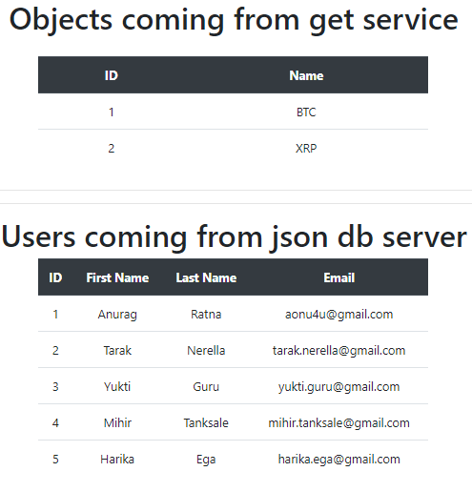

app.module.ts  
---------------------------------------------------------------------------------------------------------------------------------------

import { BrowserModule } from '@angular/platform-browser';

import { NgModule } from '@angular/core';

import { HttpClientModule } from '@angular/common/http';

import { CryptoService } from './crypto.service';

import { AppRoutingModule } from './app-routing.module';

import { AppComponent } from './app.component';

@NgModule({

  declarations: [

    AppComponent

  ],

  imports: [

    BrowserModule,

    AppRoutingModule,

    HttpClientModule

  ],

  providers: [CryptoService],

  bootstrap: [AppComponent]

})

export class AppModule { }

---------------------------------------------------------------------------------------------------------------------------------------

crypto.service.ts  
---------------------------------------------------------------------------------------------------------------------------------------

import { Injectable } from '@angular/core';

import { HttpClient,HttpHeaders } from '@angular/common/http'

import { User } from './user'

@Injectable({

  providedIn: 'root'

})

export class CryptoService {

  coins=[

    {id:1,name:"BTC"},

    {id:2,name:"XRP"}

  ];

  httpOptions = {

    headers: new HttpHeaders({'Content-Type':'application/json'})

  }

  baseURL: string = "http://localhost:3000/users";

  constructor(private _http:HttpClient) { }

  getAllUsers(){

    return this._http.get<User[]>(this.baseURL);

  }

  getItems(){

    return this.coins;

  }

}

---------------------------------------------------------------------------------------------------------------------------------------

user.ts  
---------------------------------------------------------------------------------------------------------------------------------------

export class User {

    id:number;

    firstName:string;

    lastName:string;

    email:string;

}

---------------------------------------------------------------------------------------------------------------------------------------

db.json  
---------------------------------------------------------------------------------------------------------------------------------------

{

    "users": [

      {

        "id": 1,

        "firstName": "Anurag",

        "lastName": "Ratna",

        "email": "aonu4u@gmail.com"

      },

      {

        "id": 2,

        "firstName": "Tarak",

        "lastName": "Nerella",

        "email": "tarak.nerella@gmail.com"

      },

      {

        "id": 3,

        "firstName": "Yukti",

        "lastName": "Guru",

        "email": "yukti.guru@gmail.com"

      },

      {

        "id": 4,

        "firstName": "Mihir",

        "lastName": "Tanksale",

        "email": "mihir.tanksale@gmail.com"

      },

      {

        "id": 5,

        "firstName": "Harika",

        "lastName": "Ega",

        "email": "harika.ega@gmail.com"

      }

    ]

  }

---------------------------------------------------------------------------------------------------------------------------------------

app.component.ts  
---------------------------------------------------------------------------------------------------------------------------------------

import { Component, OnInit } from '@angular/core';

import { CryptoService } from './crypto.service';

import { User } from './user'

@Component({

  selector: 'app-root',

  templateUrl: './app.component.html',

  styleUrls: ['./app.component.css']

})

export class AppComponent implements OnInit {

  coins = [];

  users:User[];

  title = 'demoproject';

  constructor(private cryptoservice:CryptoService){

    this.coins = cryptoservice.getItems();

  }

  ngOnInit(){

    this.cryptoservice.getAllUsers().subscribe( data => { this.users = data; } )

  }

}

---------------------------------------------------------------------------------------------------------------------------------------

app.component.html  
---------------------------------------------------------------------------------------------------------------------------------------

<div class="d-flex justify-content-center" >

  <h1>Objects coming from get service</h1>

</div>

<div class="d-flex justify-content-center" style="margin-top: 20px">

  <table class="table table-hover table-stripped text-center center" style="width: 30%;">

    <thead class="thead-dark align-middle">

      <th scope="col">ID</th>

      <th scope="col">Name</th>

    </thead>

    <tbody>

      <tr *ngFor="let i of coins">

        <td class="align-middle">{{i.id}}</td>

        <td class="align-middle">{{i.name}}</td>

      </tr>

    </tbody>

  </table>

</div>

<hr><hr>

<div class="d-flex justify-content-center" >

  <h1>Users coming from json db server</h1>

</div>

<div class="d-flex justify-content-center" >

  <table class="table table-hover text-center center table-reponsive" style="width: 30%;">

    <thead class="thead-dark align-middle">

      <th scope="col">ID</th>

      <th scope="col">First Name</th>

      <th scope="col">Last Name</th>

      <th scope="col">Email</th>

    </thead>

    <tbody>

      <tr *ngFor="let u of users">

        <td>{{u.id}}</td>

        <td>{{u.firstName}}</td>

        <td>{{u.lastName}}</td>

        <td>{{u.email}}</td>

      </tr>

      <tr *ngIf="!users || users.length==0">

        <th colspan="4">

          <p class="text-center text-danger">No users to show...</p>

        </th>

      </tr>

    </tbody>

  </table>

</div>

<router-outlet></router-outlet>

---------------------------------------------------------------------------------------------------------------------------------------